Stop and Start of GLS Elastic Search Server



Document Reference Number – L3-271/2.xxx

**Version 0.1 D**

[](https://spo.mcd.com/sites/corp_itr_eas/team/eCP/)

**Document Control Record**

|  |  |
| --- | --- |
| Title |  |
| Version | 0.1 |
| Author | Aman Shrivastava |
| Approver | Ajay Garipally |
| Owner | DSS Middleware |
| Prepared By | Aman Shrivastava |
| Category | Middleware |
| Date Of Creation | 08/01/2018 |

**Issue and Amendments Record**

|  |  |  |  |  |  |
| --- | --- | --- | --- | --- | --- |
| Version | Revise  Date | Revised  By | Review  Date | Reviewed  By | Comment/Function Requested |
| 0.1 |  |  |  |  | Initial draft version |

**Table of Content**

Purpose of the Document 4

Basic Information/Prerequisites 4

Troubleshooting 4-6

Step 1: - Go inside Elastic Search Server say ‘10.1.37.48’ by using command ‘ssh 10.1.37.48’ 4

Step 2: - Use command ‘sudo su –’ to have root level permissions ……………………………………........5

Step 3: - Use command ‘ ps –ef | grep -i elasticsearch* ’ ………… ……………………………………........6

Step 4: - Use command ‘sudo service elasticsearch stop’ for stopping elasticsearch service on the Elastic Search Server …………………………………………………………………………………………….........7

Step 5: - Use command ‘ps –ef | grep -i elasticsearch*’ for confirming that the elasticsearch service has stopped or not ………………..………………………………………………………………………….........7

Step 6: - Use command ‘sudo service elasticsearch start’ for starting elasticsearch service on the Elastic Search Server …………………………………………………………………………………………….........7

Step 7: - Use command ‘ps –ef | grep -i elasticsearch*’ for confirming that the elasticsearch service has started or not …………………………………………………………………………………………….........7

Technical Validation:……………………………………………………….………………………………………………………………………..….8-9

1. **Use command “ curl -XGET 'http://localhost:9200/_snapshot/_all?pretty' ” for validation of properties of Elastic Search Server………………………………………………………………………………………….8**

**2. Use command “ curl -XGET 'http://localhost:9200/_cat/indices?v' ” for validation of indices of Elastic Search Server if they are green or not …………………………………………………………………………8**

**3. Use command “ curl -XGET 'http://localhost:9200/stores/store/_count' -d ' { "query" : { "match" : { "marketCode": "US" }}}' ” for validation of shards of Elastic Search Server if they are successful or failed**

**4.** We can use GLS Fiddler calls also for validation ………………………………………………………………………………………….9

# Purpose of the Document

1. This document can be used for Stop and Start of GLS Elastic Search Server.

# Basic Information/Prerequisites

1. The activity is performed through Jump Server ‘10.1.44.19’.

# Troubleshooting

## Step 1: Go inside Elastic Search Server say ‘10.1.37.48’ by using command ‘ssh 10.1.37.48’ -:

**Note**: You must use ‘sudo su – ‘ before to have root permission before using ‘ssh 10.1.37.48’

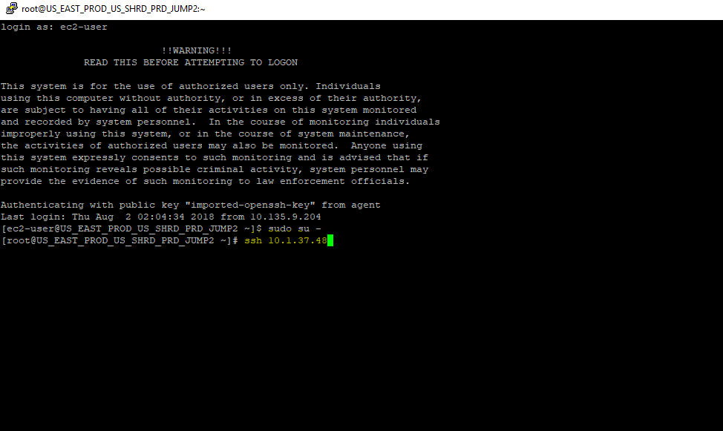

## Step 2: - Use command ‘sudo su –’ to have root level permissions :

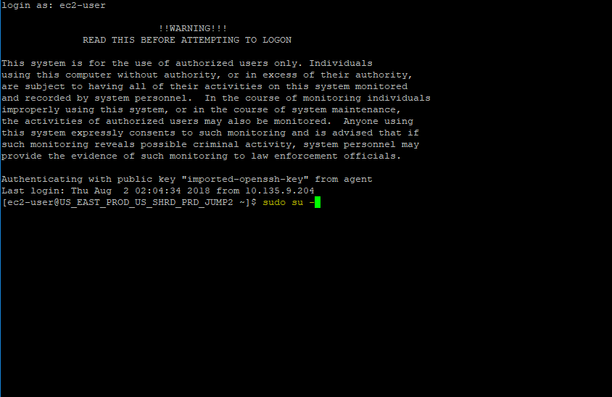

## Step 3: Use command ‘ ps –ef | grep -i elasticsearch* ’ :

**Expected output will be:**

498 1314 1 6 23:08 ? 00:00:20 /usr/bin/java -Xms256m -Xmx1g -Djava.awt.headless=true -XX:+UseParNewGC -XX:+UseConcMarkSweepGC -XX:CMSInitiatingOccupancyFraction=75 -XX:+UseCMSInitiatingOccupancyOnly -XX:+HeapDumpOnOutOfMemoryError -XX:+DisableExplicitGC -Dfile.encoding=UTF-8 -Delasticsearch -Des.pidfile=/var/run/elasticsearch/elasticsearch.pid -Des.path.home=/usr/share/elasticsearch -cp :/usr/share/elasticsearch/lib/elasticsearch-1.7.1.jar:/usr/share/elasticsearch/lib/*:/usr/share/elasticsearch/lib/sigar/* -Des.default.path.home=/usr/share/elasticsearch -Des.default.path.logs=/var/log/elasticsearch -Des.default.path.data=/var/lib/elasticsearch -Des.default.path.work=/tmp/elasticsearch -Des.default.path.conf=/etc/elasticsearch org.elasticsearch.bootstrap.Elasticsearch

root 2365 2290 0 23:13 pts/0 00:00:00 grep -i elasticsearch*

## Step 4: Use command ‘sudo service elasticsearch stop’ for stopping elasticsearch service on the Elastic Search Server:

## Step 5: Use command ‘ps –ef | grep -i elasticsearch*’ for confirming that the elasticsearch service has stopped or not:

## Step 6: Use command ‘sudo service elasticsearch start’ for starting elasticsearch service on the Elastic Search Server:

## Step 7: Use command ‘ps –ef | grep -i elasticsearch*’ for confirming that the elasticsearch service has started or not:

**Expected output will be:**

498 1314 1 6 23:08 ? 00:00:20 /usr/bin/java -Xms256m -Xmx1g -Djava.awt.headless=true -XX:+UseParNewGC -XX:+UseConcMarkSweepGC -XX:CMSInitiatingOccupancyFraction=75 -XX:+UseCMSInitiatingOccupancyOnly -XX:+HeapDumpOnOutOfMemoryError -XX:+DisableExplicitGC -Dfile.encoding=UTF-8 -Delasticsearch -Des.pidfile=/var/run/elasticsearch/elasticsearch.pid -Des.path.home=/usr/share/elasticsearch -cp :/usr/share/elasticsearch/lib/elasticsearch-1.7.1.jar:/usr/share/elasticsearch/lib/*:/usr/share/elasticsearch/lib/sigar/* -Des.default.path.home=/usr/share/elasticsearch -Des.default.path.logs=/var/log/elasticsearch -Des.default.path.data=/var/lib/elasticsearch -Des.default.path.work=/tmp/elasticsearch -Des.default.path.conf=/etc/elasticsearch org.elasticsearch.bootstrap.Elasticsearch

root 2365 2290 0 23:13 pts/0 00:00:00 grep -i elasticsearch*

## Technical Validation

1. **Use command “ curl -XGET 'http://localhost:9200/_snapshot/_all?pretty' ” for validation of properties of Elastic Search Server .**

**Expected output will be:**

{

"my_s3_repository" : {

"type" : "s3",

"settings" : {

"region" : "us-east-1",

"bucket" : "gls-prod-elastic-snapshot"

}

}

}

1. **Use command “ curl -XGET 'http://localhost:9200/_cat/indices?v' ” for validation of indices of Elastic Search Server if they are green or not .**

**Expected output will be:**

|  |  |  |  |  |  |  |  |  |
| --- | --- | --- | --- | --- | --- | --- | --- | --- |
| health | status | index | pri | rep | docs.count | docs.deleted | store.size | pri.store.size |
| green | open | stores-1-7-1-20170426 | 5 | 1 | 133376 | 24 | 63.6mb | 31.7mb |
| green | open | stores | 5 | 1 | 20584 | 25 | 46.9mb | 23.4mb |
| green | open | markets | 5 | 1 | 23 | 0 | 171kb | 85.5kb |
| green | open | glsreports | 10 | 1 | 104225 | 0 | 31.2mb | 15.6mb |

1. **Use command “ curl -XGET 'http://localhost:9200/stores/store/_count' -d ' { "query" : { "match" : { "marketCode": "US" }}}' ” for validation of shards of Elastic Search Server if they are successful or failed.**

**Expected output will be:**

**{"count":14078,"_shards":{"total":5,"successful":5,"failed":0}}**

1. We can use GLS Fiddler calls also for validation :

